**Excel Assignment - 6**

**1. What are the various elements of the Excel interface? Describe how they're used.**

1. Quick Access Toolbar

This toolbar is located in the upper left corner of the screen. Its objective is to show the most frequently used Excel commands. We can customize this toolbar based on our preferred commands.

### 2. File Tab

Excel 2007's Office button has been replaced by the File tab. We can click it to check the Backstage view, where we can open or save files, create new sheets, print sheets, and perform other file-related operations.

### 3. Title Bar

The title bar of the spreadsheet is at the top of the window. It displays the active document's name.

### 4. Control Buttons

Control buttons are the symbols that are present in the upper-right side of the window, enabling us to change the labels, minimize, maximize, share, and close the sheet.

### 5. Menu Bar

Under the diskette or save icon or the excel icon (this will depend on the version of the program), labels or bars which enable changing the sheet which is shown. These are the menu bar and contain a File, Insert, Page Layout, Formulas, Data, Review, View, Help, and a Search Bar with a light bulb icon. These menus are divided into subcategories which simplify the distribution of information and analysis of calculations.

**2. Write down the various applications of Excel in the industry.**

**Application of MS Excel**

* Data Entry and Storage.
* Performing Calculations.
* Data Analysis and Interpretation.
* Reporting and Visualizations.
* Accounting and Budgeting.
* Collection and Verification of Business Data.
* Calendars and Schedules.
* Administrative and Managerial Duties.

**3. On the ribbon, make a new tab. Add some different groups, insert commands in the groups and name them according to their commands added. Copy and paste the screenshot of the steps you followed.**

**Step 1:** Open the Excel Options and click on Customize Ribbon.

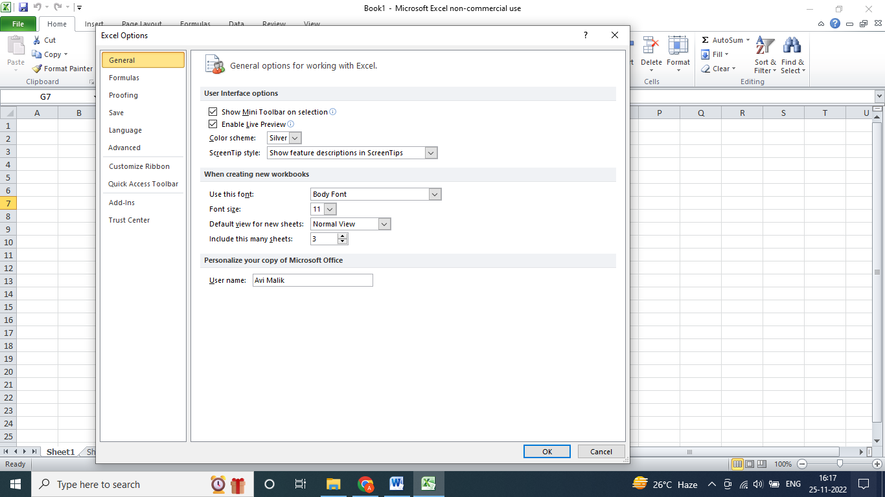

**Step 2:** Click on New Tab.

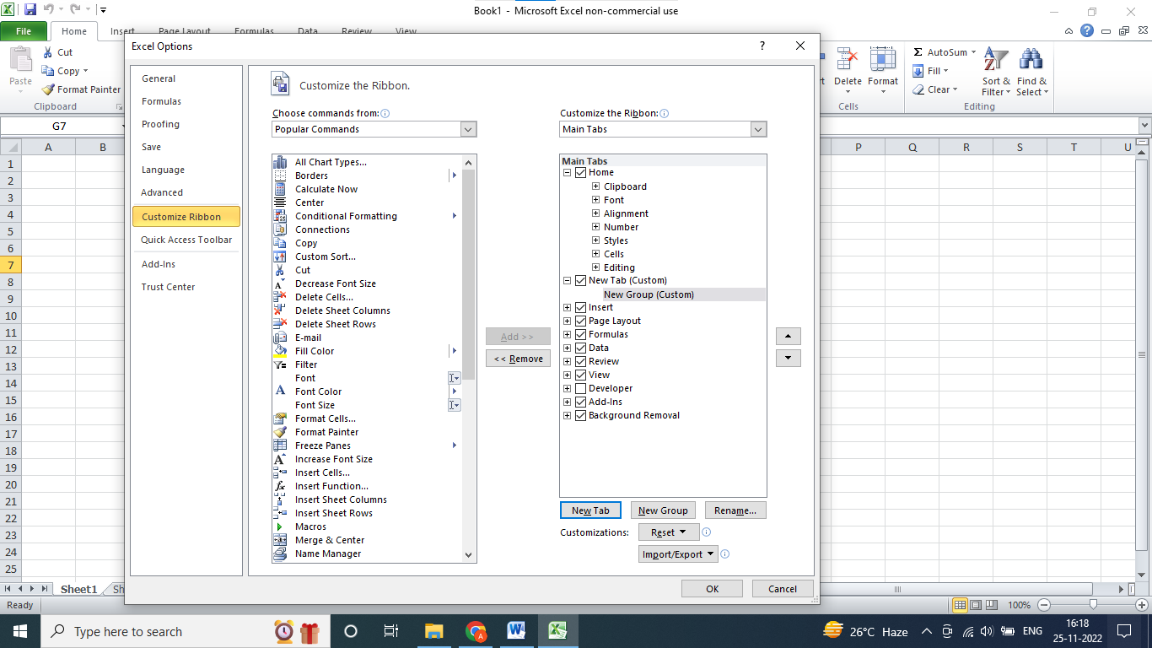

**Step 3:** Rename it “My Own Tab”. Press OK.

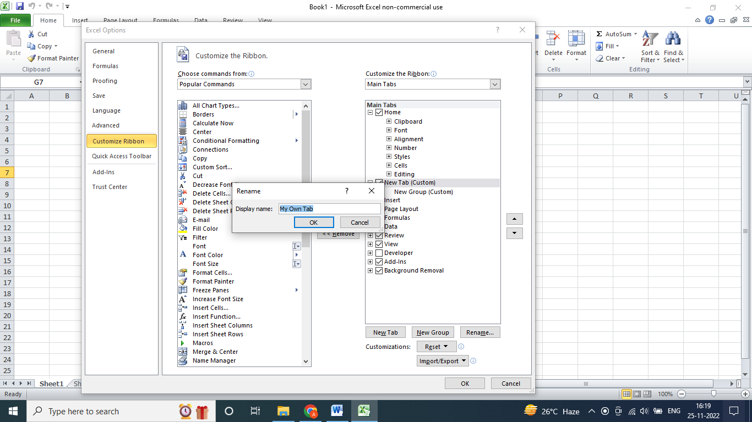

**Step 4:** Add the commands from the Command dialogue box. These commands will be added in the Group “Group1” which has been created under “My Own Tab”. Press OK.

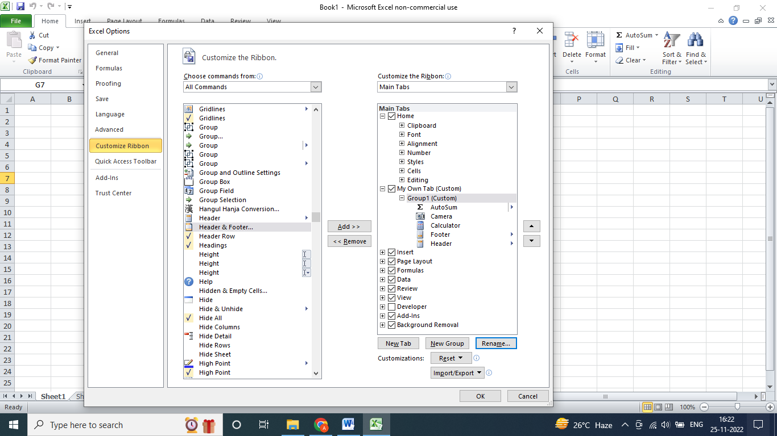

**Step 5:** New Tab and the New Group has been created.

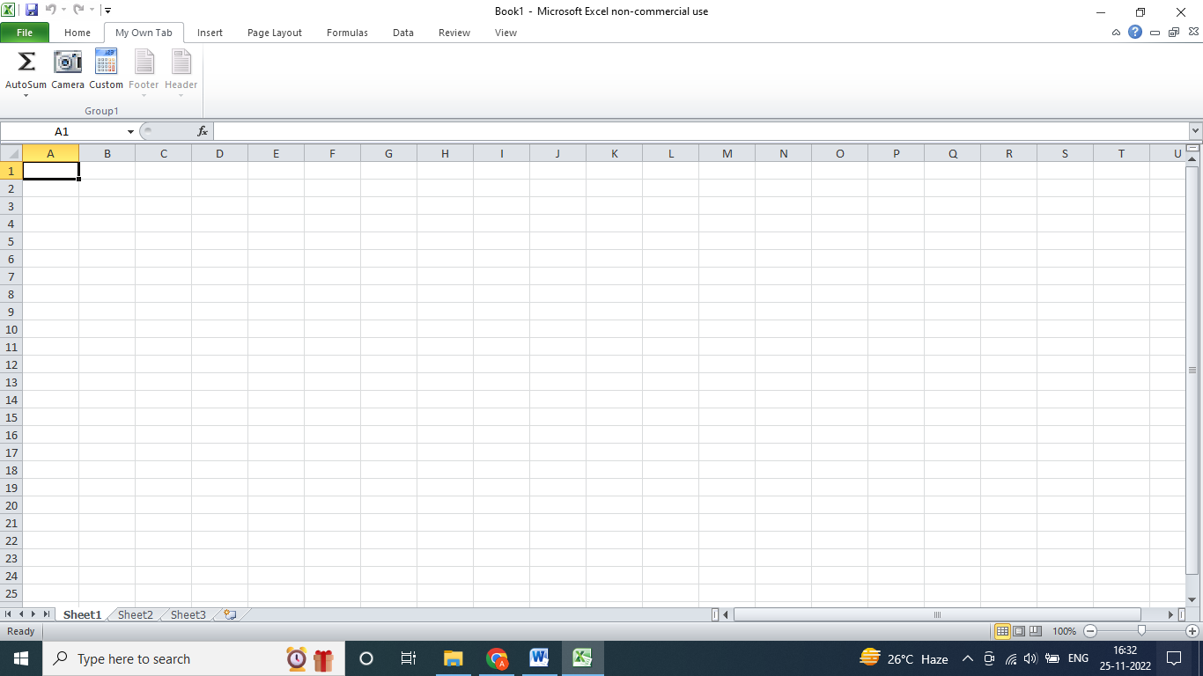

**4. Make a list of different shortcut keys that are only connected to**

**formatting with their functions.**

Ctrl+C → Copy selected text or graphics to the Office Clipboard. Ctrl+V → Paste the most recent addition to the Office Clipboard. Ctrl+Shift+A → Format all letters as capitals. Ctrl+B → Applies or removes bold formatting.

**5. What distinguishes Excel from other analytical tools?**

You can do a lot of things with Excel: modeling, visualization, reports, dynamic charts, etc. It can help you understand the meaning of many operations before further learning other tools (such as Python and R).

**6. Create a table and add a custom header and footer to your table.**

